NOTICE OF POSSIBLE QUORUM
OF THE NBU BOARD of Trustees
AT THE COMMUNITY ADVISORY PANEL MEETING
McKenna Events Center, 801 W. San Antonio Street
New Braunfels, Texas 78130
March 19, 2024, at 9:00 AM
www.nbutexas.com
NOTICE OF POSSIBLE QUORUM
A quorum of the members of the New Braunfels Utilities Board of Trustees (NBU Board Members) may attend the NBU Community Advisory Panel (CAP) meeting on Tuesday, March 19, 2024, at 9:00 am. No formal action will be taken by the NBU Board Members.
The CAP meeting is not a regularly scheduled meeting of the NBU Board Members, but because a quorum of NBU Board Members may be in attendance, this notice is being posted in compliance with the Texas Open Meetings Act in the event that any NBU-related business is discussed.

CERTIFICATE OF POSTING
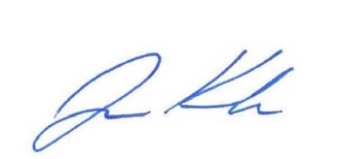
I, Ryan Kelso, Secretary to the Board of Trustees, do hereby certify that this Notice of Possible Quorum was posted at the City of New Braunfels City Hall, 550 Landa Street, New Braunfels, Texas, and New Braunfels Utilities Main Office, 263 Main Plaza, New Braunfels, Texas, on the 14th day of March 2024, and remained posted continuously for at least 72 hours preceding the scheduled time of the meeting.

_____________________________
Ryan Kelso, Chief Executive Officer
Secretary to the Board of Trustees

